There really wasn’t any instruction in this activity guide. Most of the written content was concerning how they would implement the game logic rather than the database side of things. I therefore did my best and used MySQL Workbench to just create the ER diagram with the tables and their connection to one another. This activity would have been much more worthwhile/beneficial if the instructions were more focused on teaching.

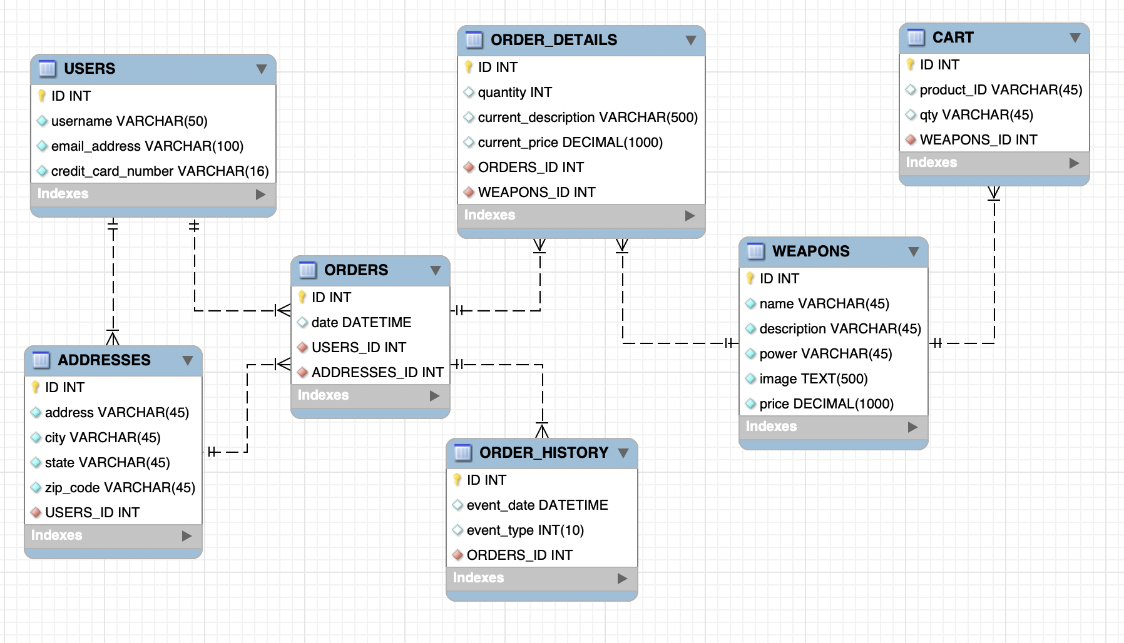

Figure : ER Diagram. The ER diagram shows both the logical and physical layout for the proposed database in an easy to read and understand format.

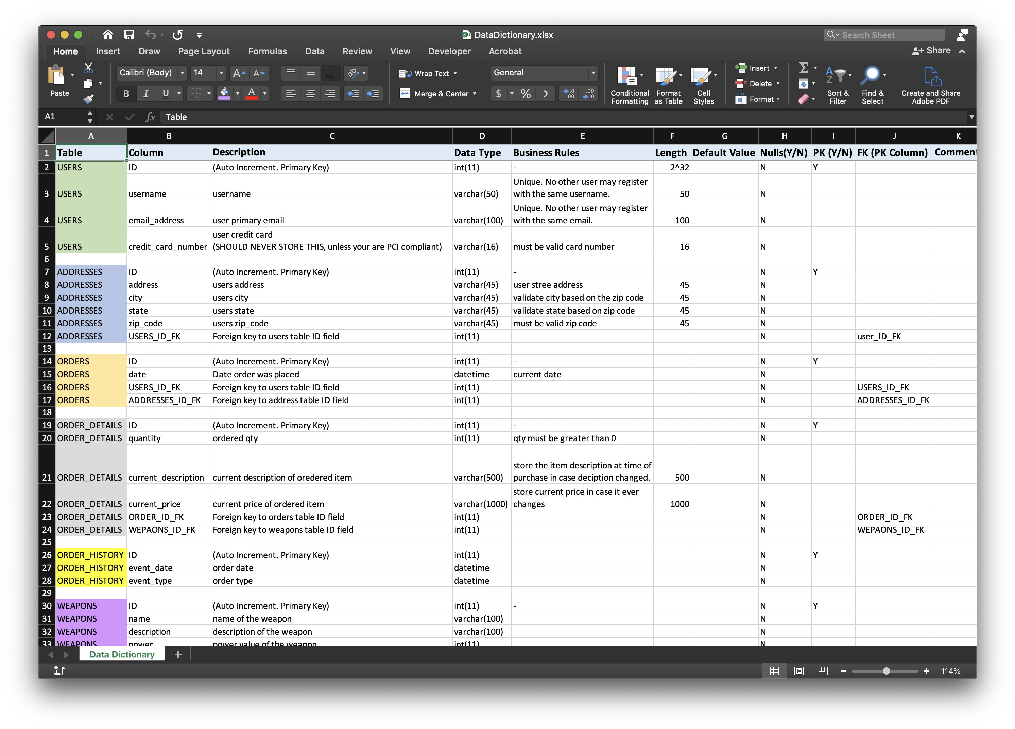

Figure : See included Excel document for completed data dictionary

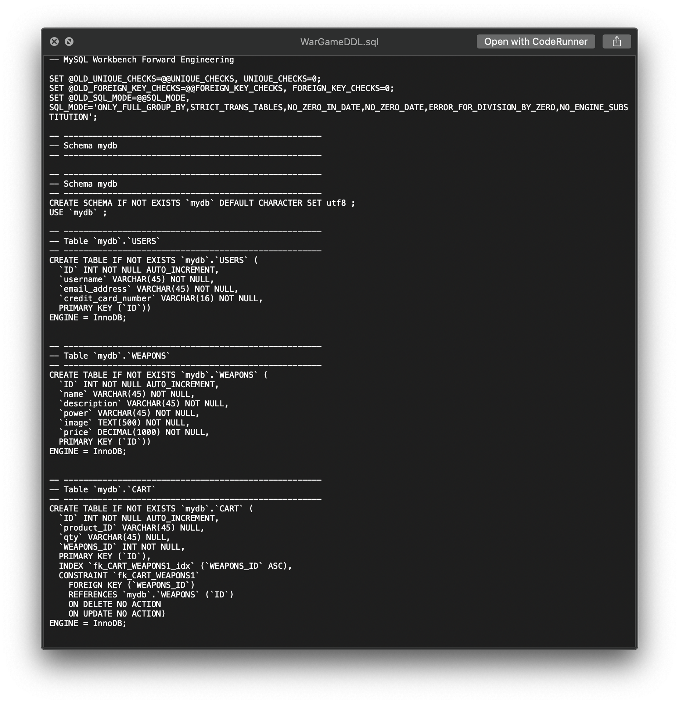

Figure : See included .sql file for DDL script